Jyle Darling

M093437

APPLICATION test cAses

AT2-SPRINT 2

Table of Contents

Test Cases 1

Test Case Images 2

# Test Cases

|  |  |  |  |  |
| --- | --- | --- | --- | --- |
| **Test Case** | **Description** | **Expected Result** | **Actual Result** | **Comments** |
| 01. | Signing up as a new member to the monthly newsletter and breaking news. | Message to be displayed showing successful sign up. Details added to the database. | As expected. | Ref figures 1 and 2. |
| 02. | Unsubscribing from membership. Email address is in the database. | Clicking unsubscribe button provides a space for an email to be entered. Entering email will provide a message showing un-subscription was successful. Email sent to admin account. | As expected. | Ref figure 3 and 4. |
| 03. | Unsubscribing from membership. Email address is not in the database. | Message displayed showing email address is not in the database. | Message displayed showing un-subscription was successful. | Ref figure 5 and 6. |
| 04. | Logging in as administrator with invalid details. | Message displayed showing details not found. Access not granted. | As expected. | Ref figures 7 and 8. |
| 05. | Logging in as administrator with valid details. | Admin only navigation bar, and current membership table to show. | As expected. | Ref figure 9 and 10. |
| 06. | Pressing unsubscribe membership nav bar, removing email address that is flagged. | Table of members wishing to unsub is shown, removing a member via button or manual email entry removes them from the database. | As expected. | Ref figure 11 and 12. |
| 07. | Unsubscribing a member without member request. | Message displayed showing action could not complete. | As expected. | Ref figure 13. |
| 08. | All membership table clicked. | Tables shown that contains all members currently stored in the database. | As expected. | Ref figure 14. |
| 09. | Admin logging out. | After selecting logout user is taken back to home page, access to admin pages has been removed. | As expected. | Ref figure 15 and 16. |
| 10. | Attempting to sign up as a new member with invalid email format. | Popup message to show showing current error in email format. | As expected. | Ref figure 17. |
| 11. | Attempting malicious code via user input fields throughout the website. | Malicious script not to be executed. | As expected. | No images to display. |

# Test Case Images

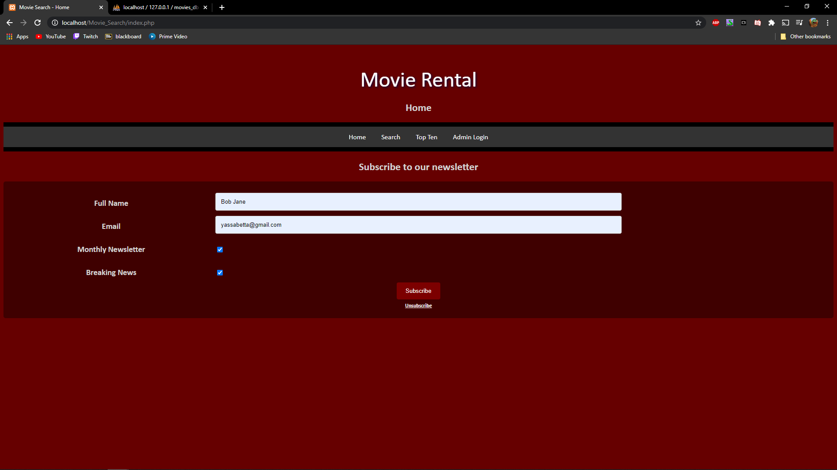

Figure 1

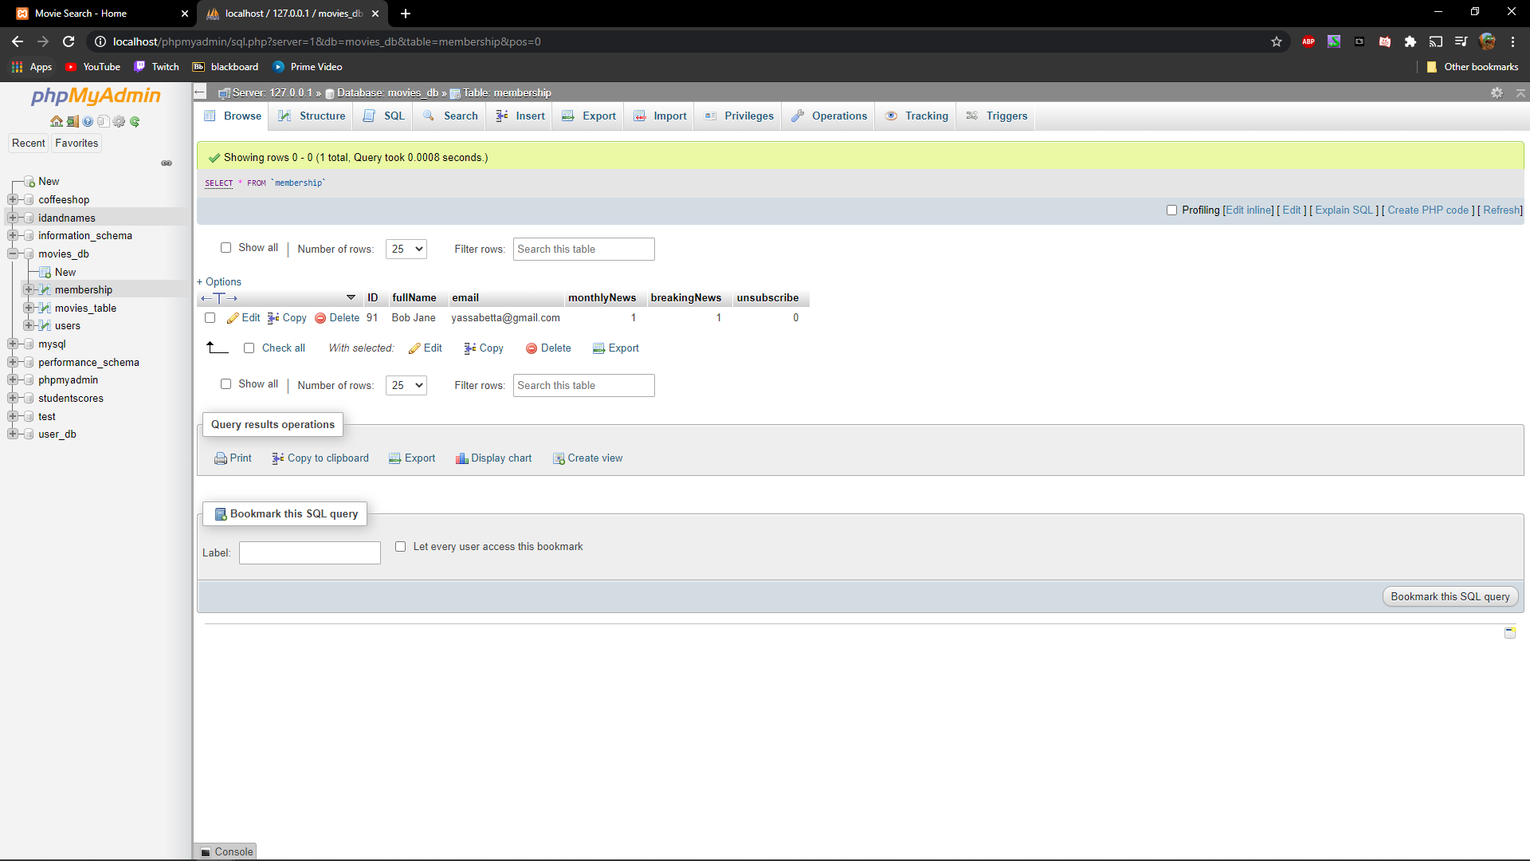

Figure 2

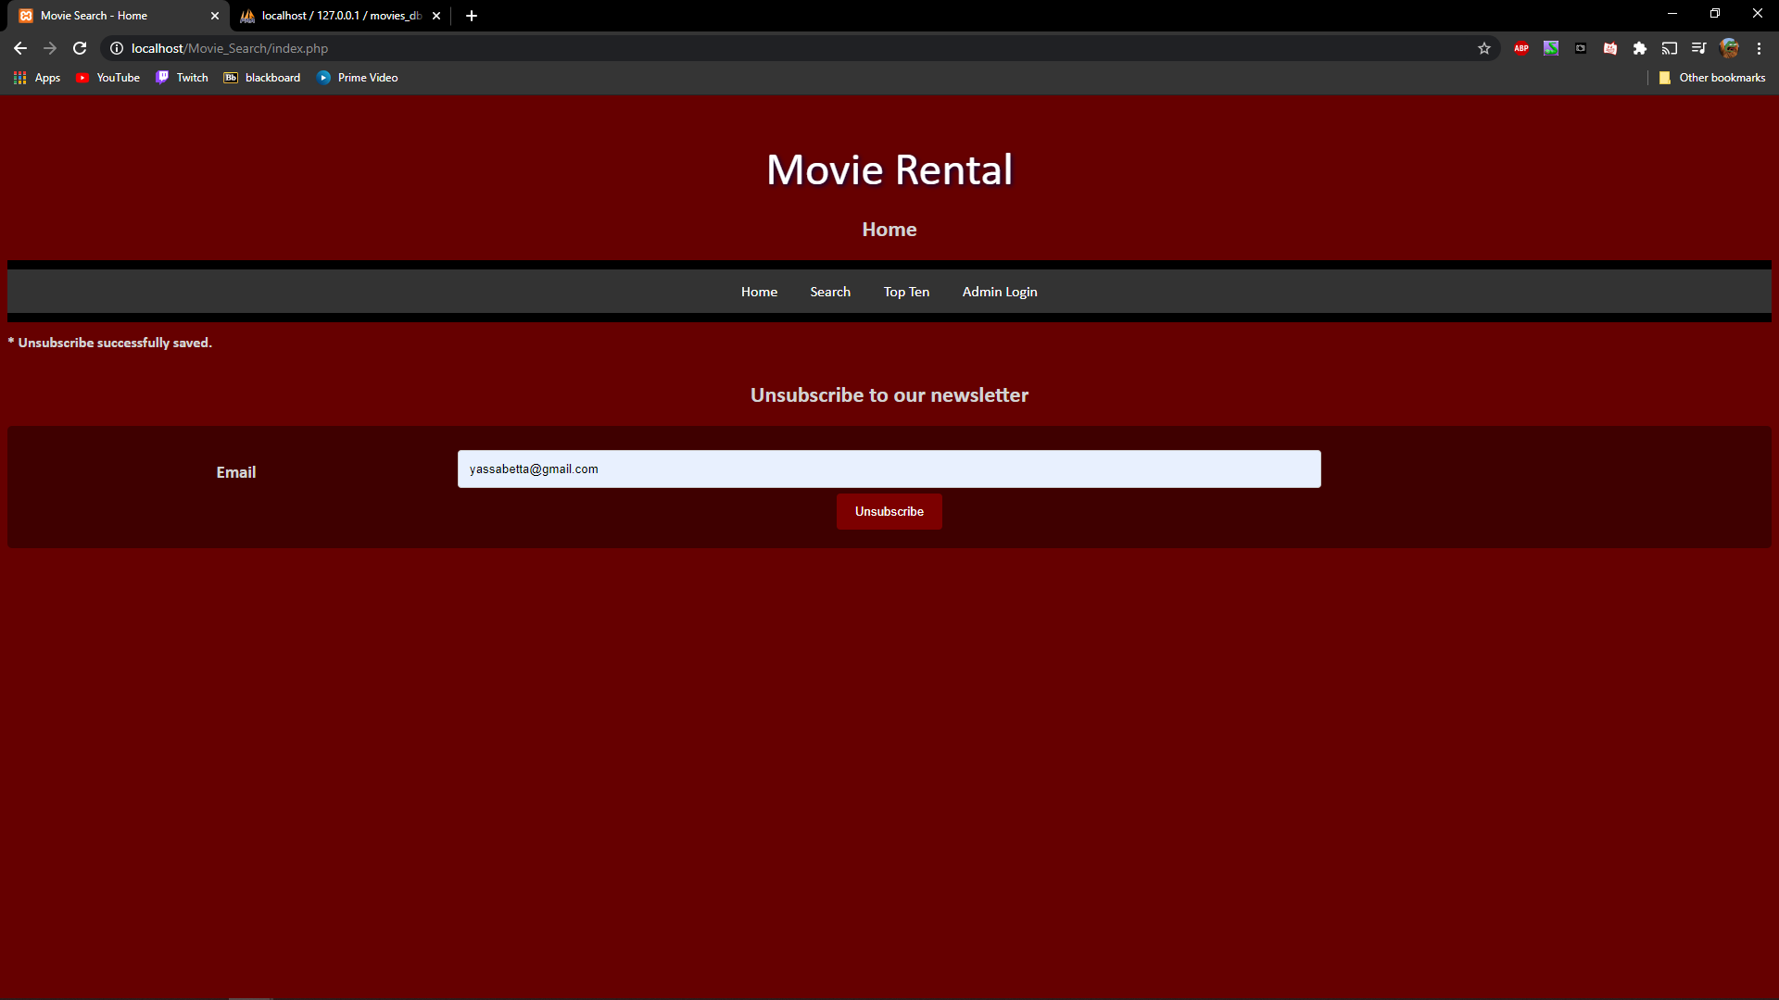

Figure 3

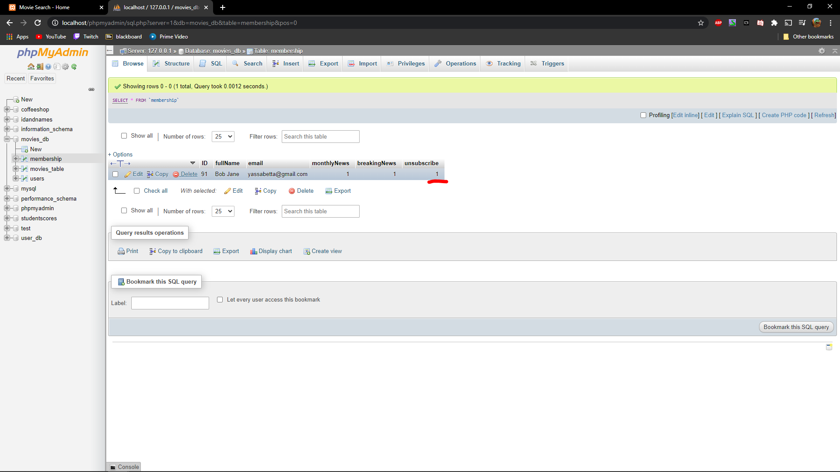

Figure 4

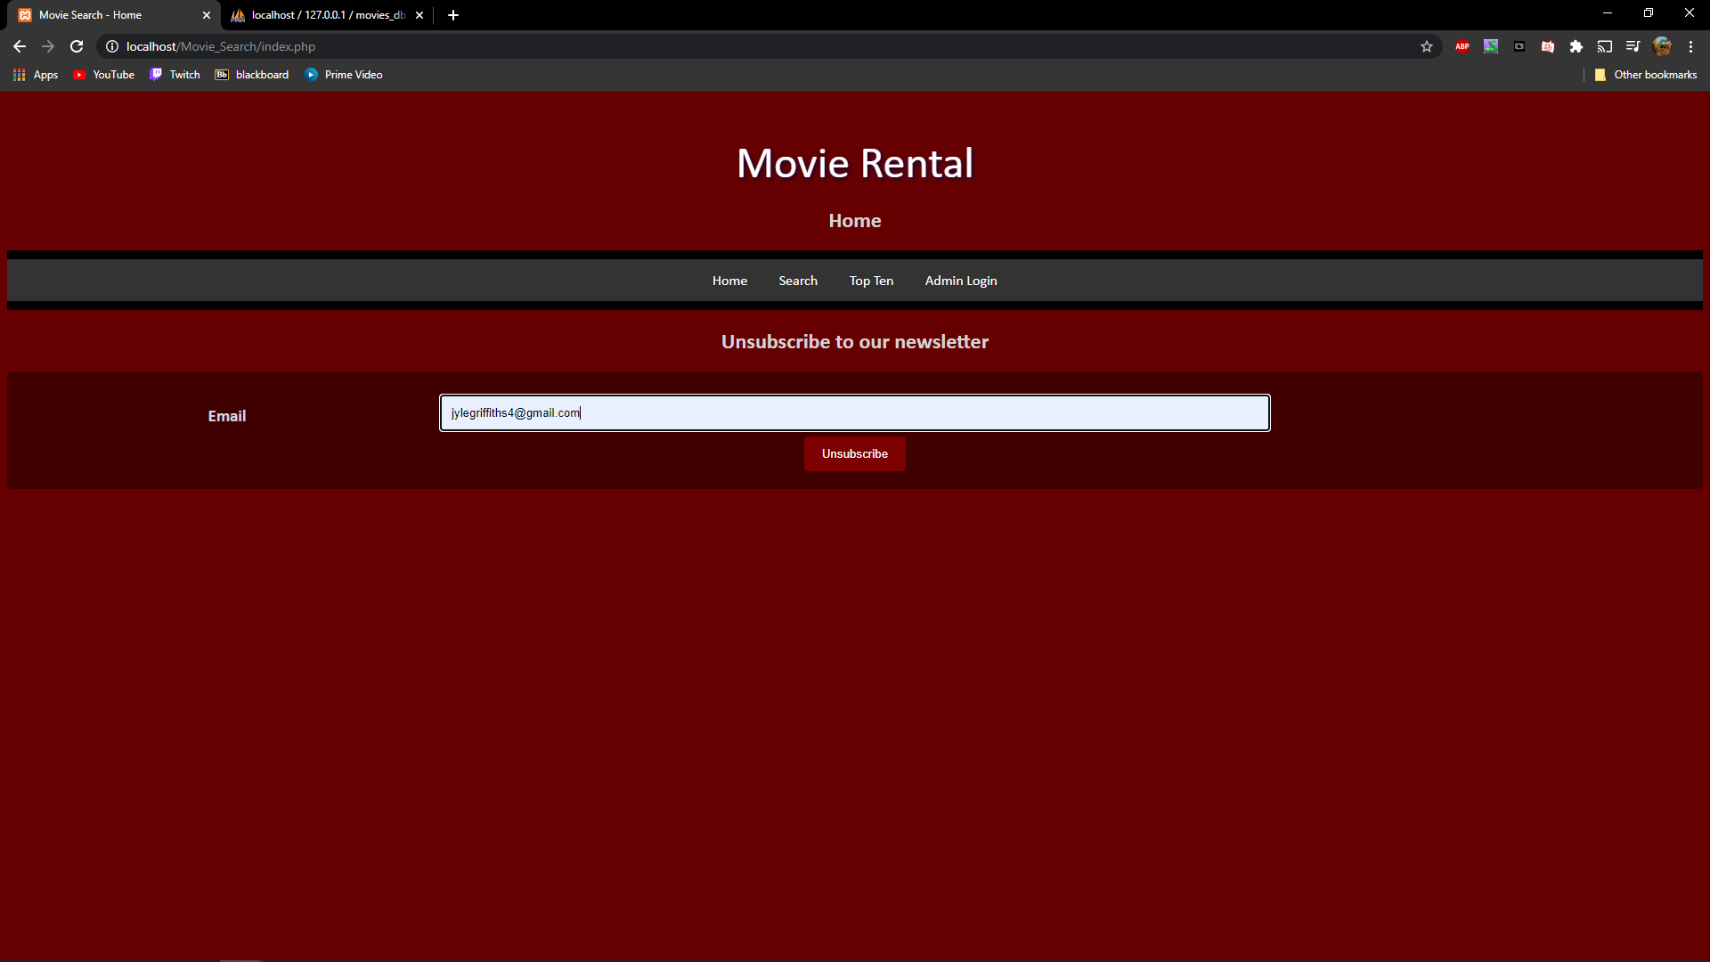

Figure 5

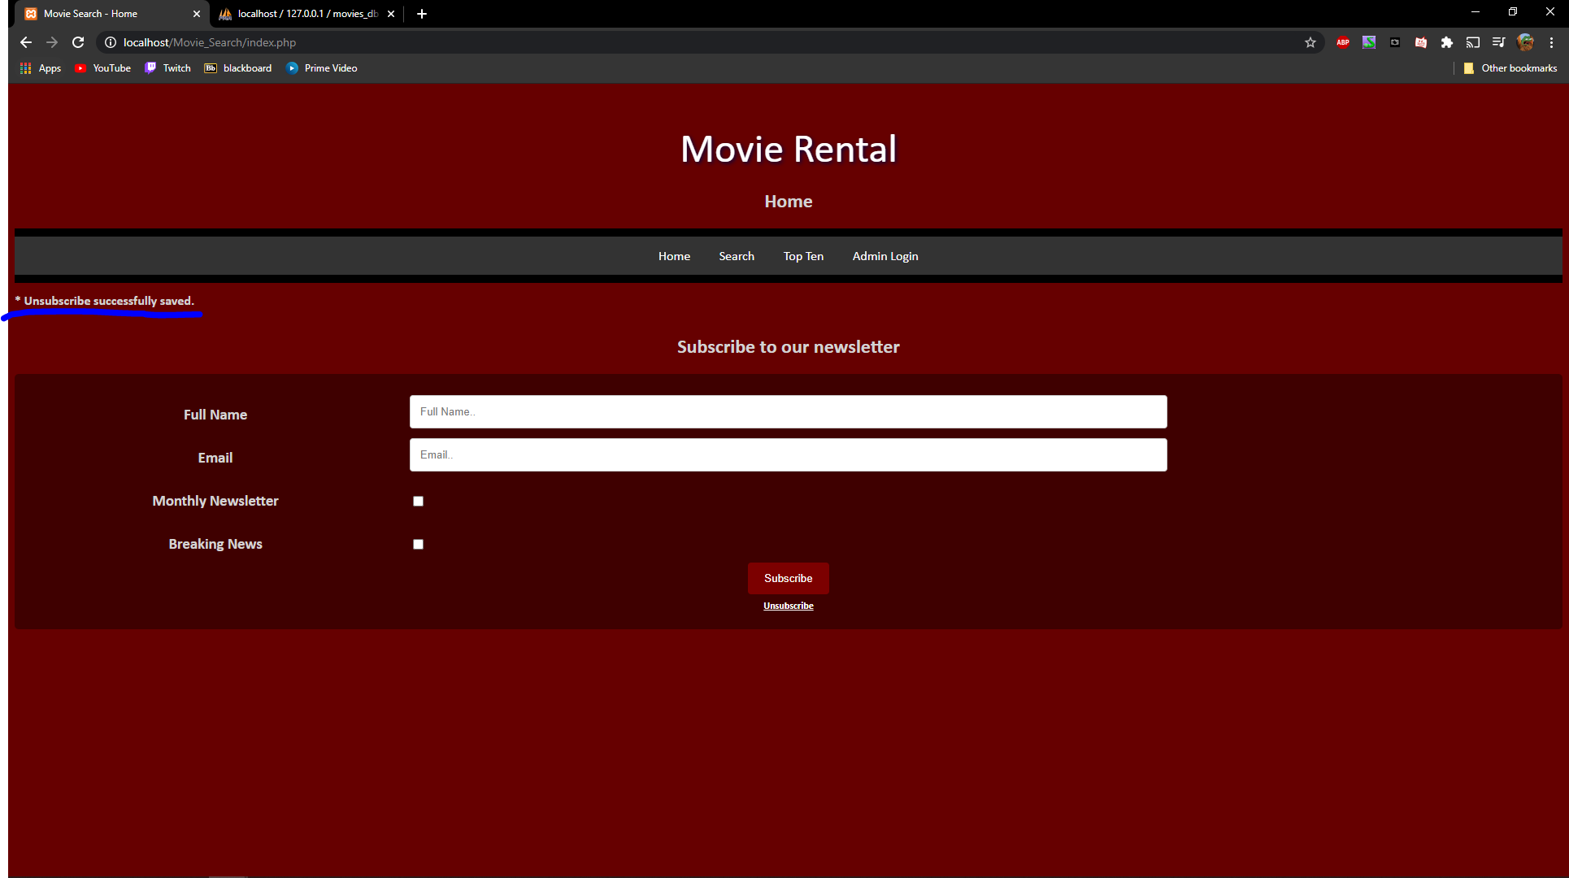

Figure 6

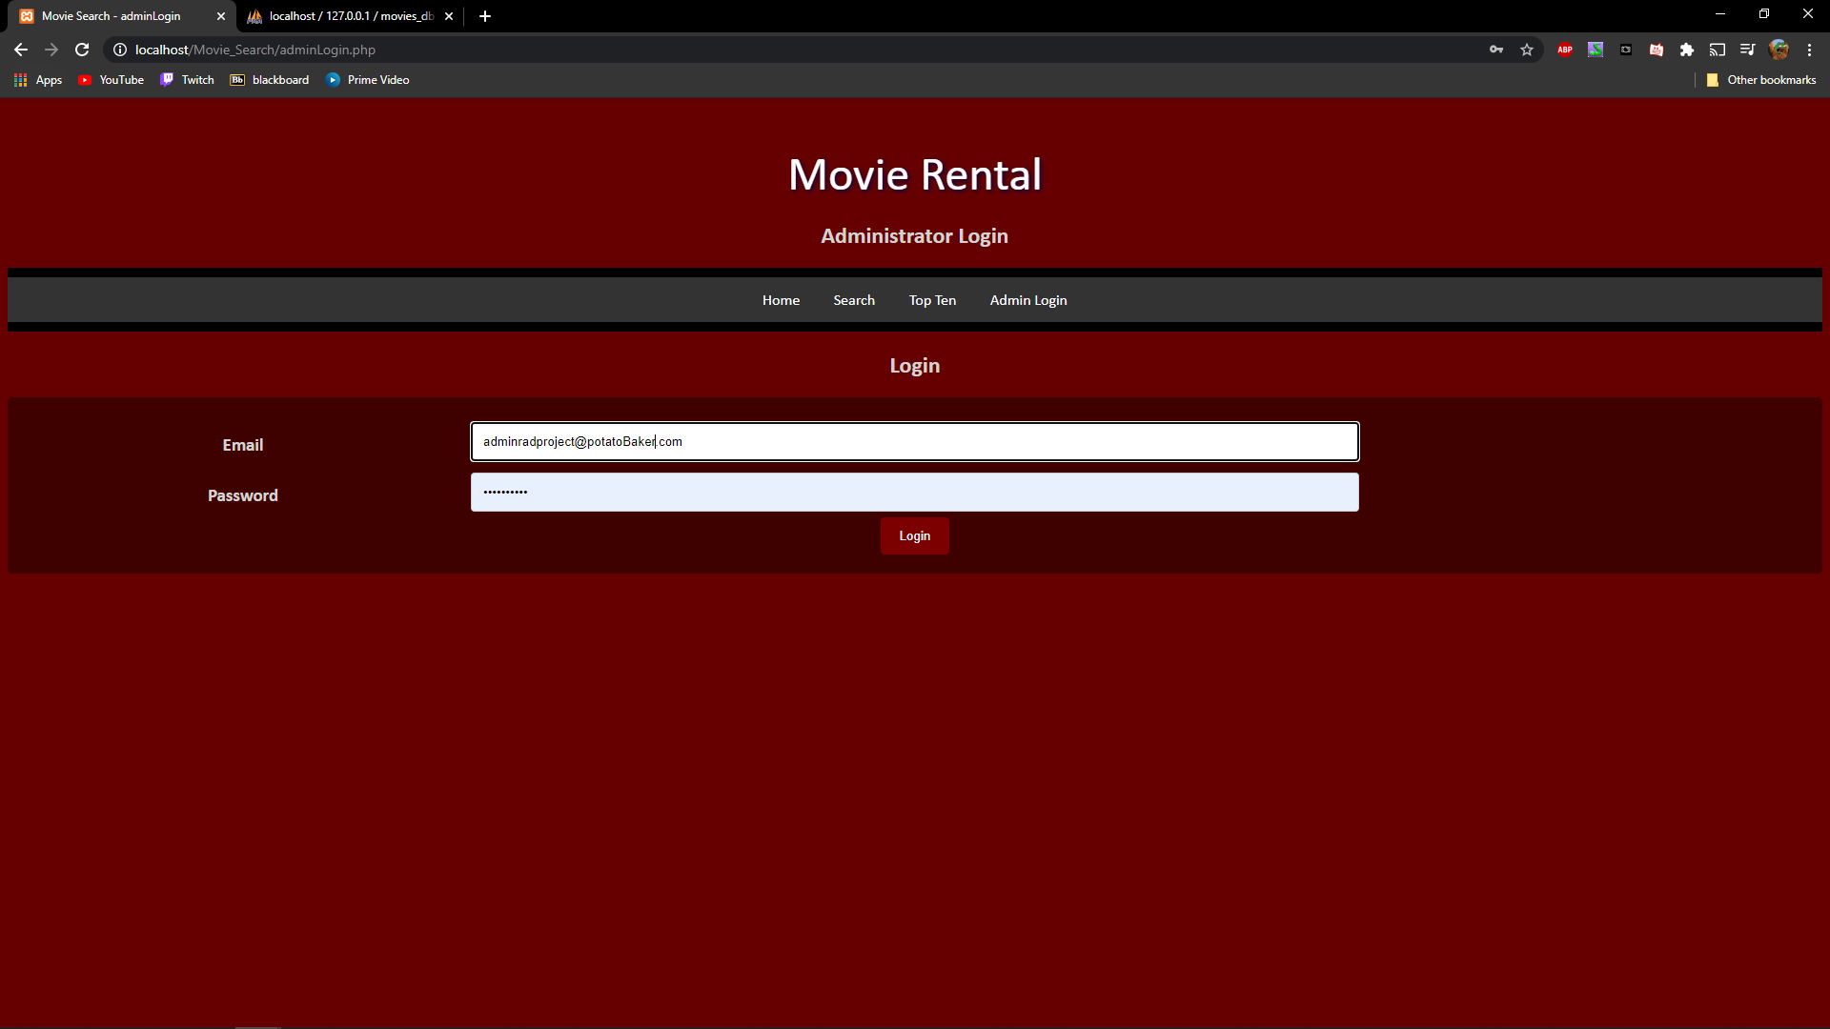

Figure 7

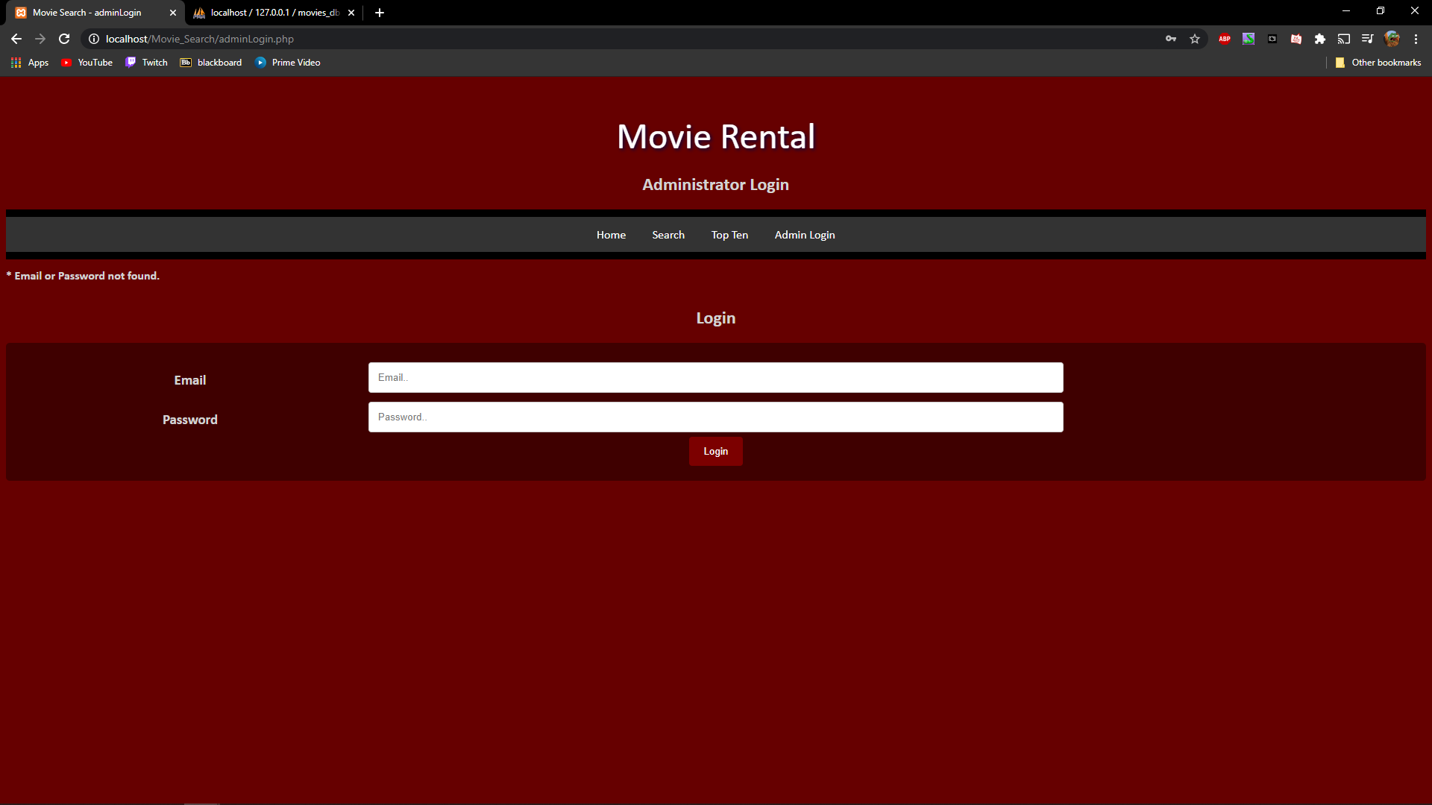

Figure 8

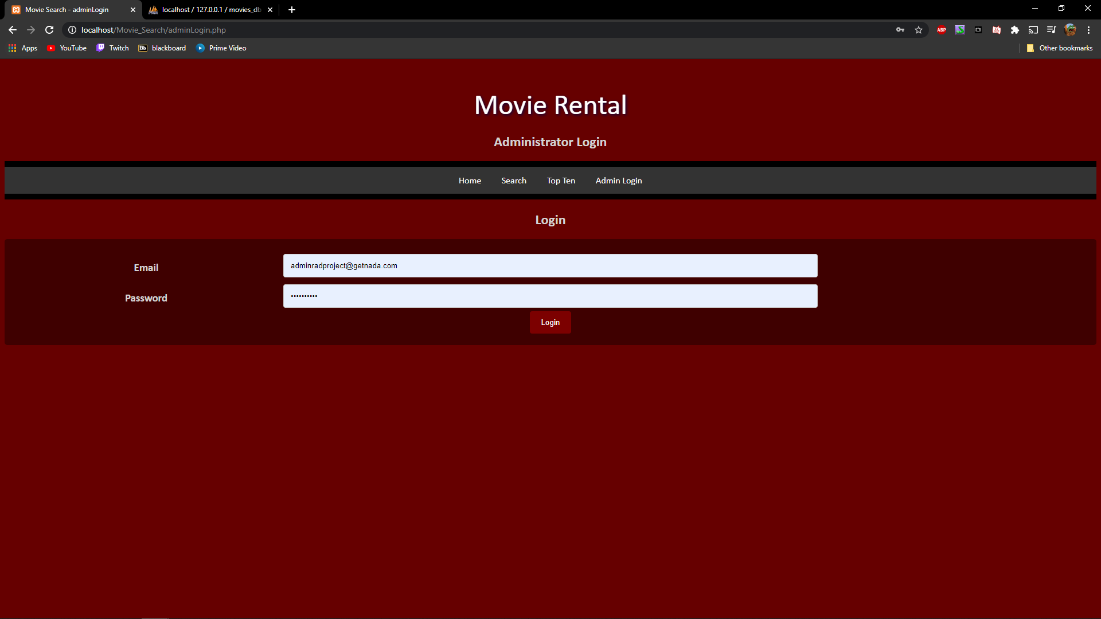

Figure 9

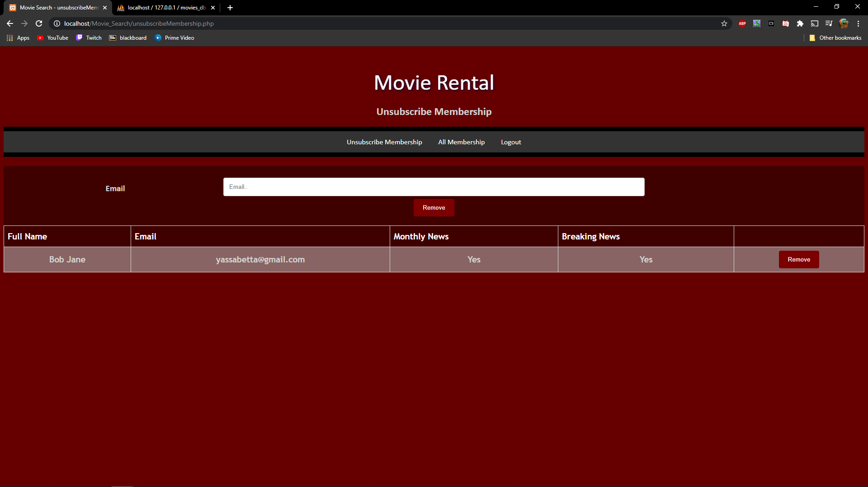

Figure 10

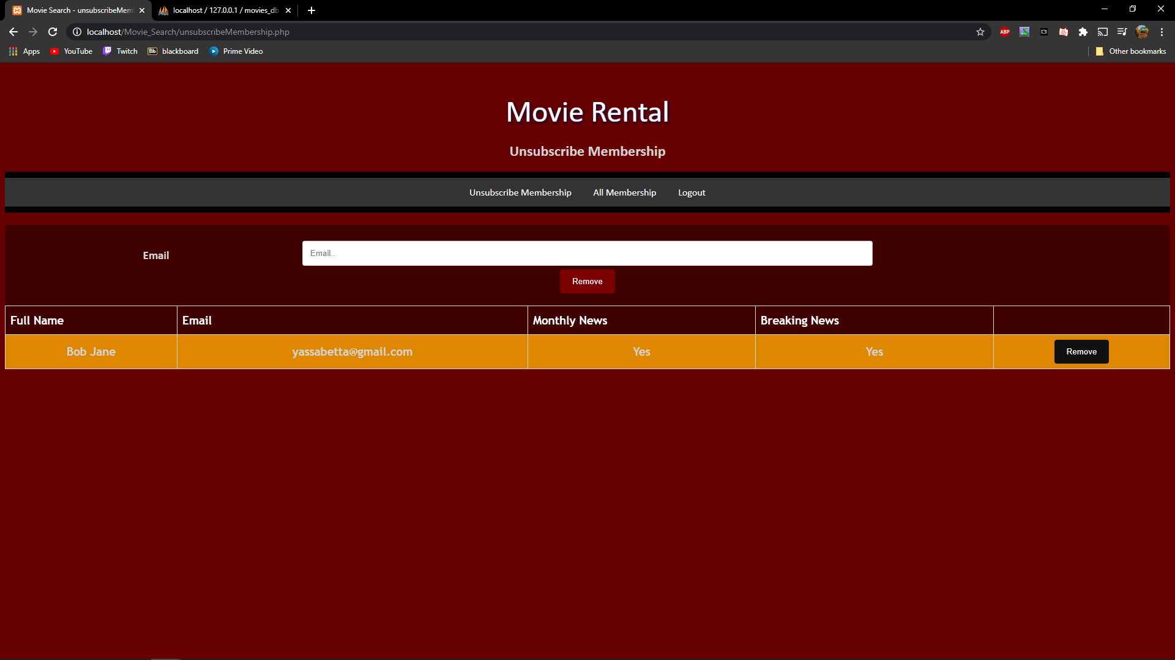

Figure 11

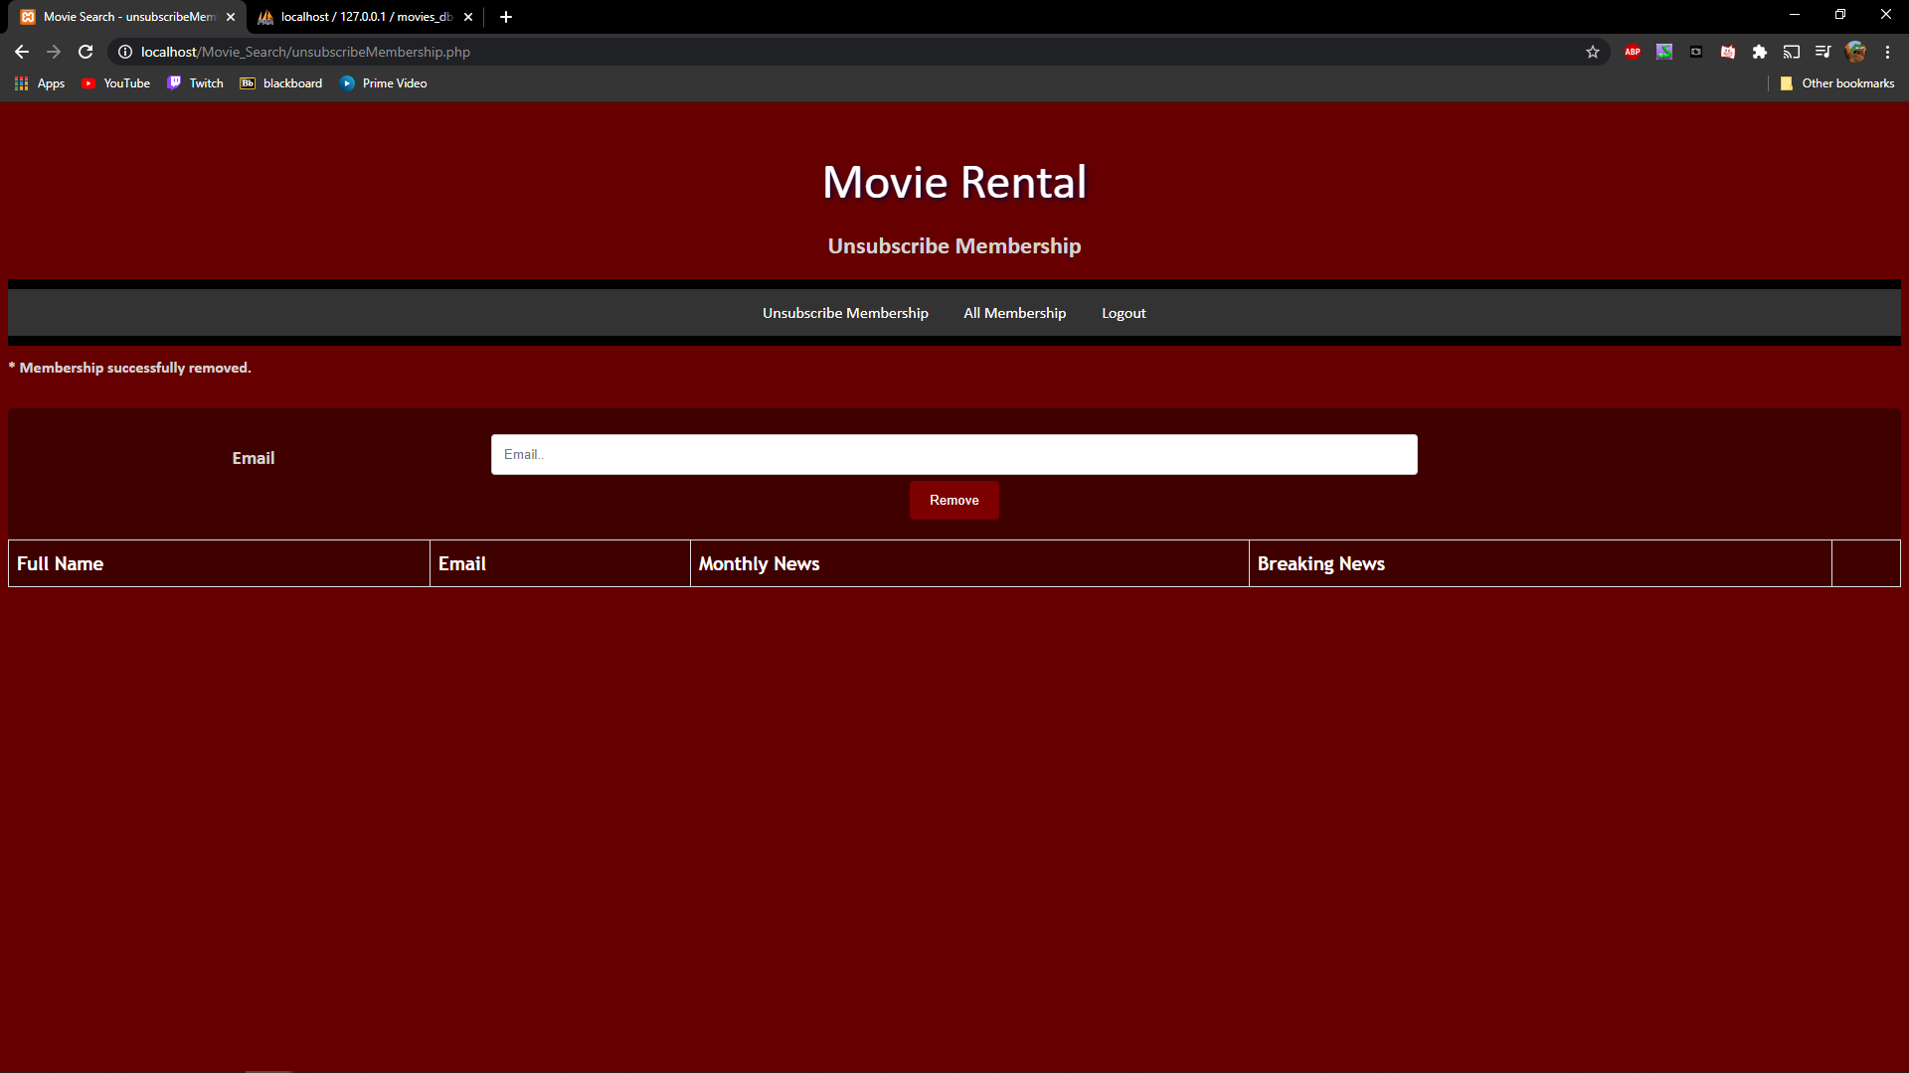

Figure 12

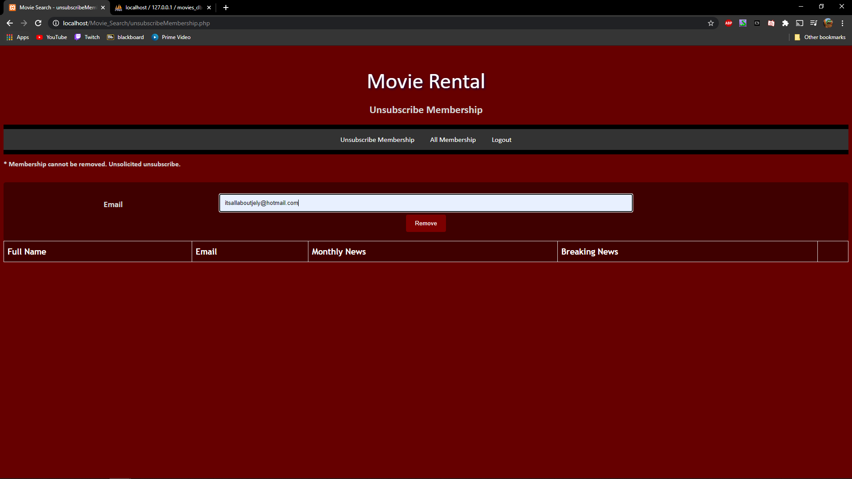

Figure 13

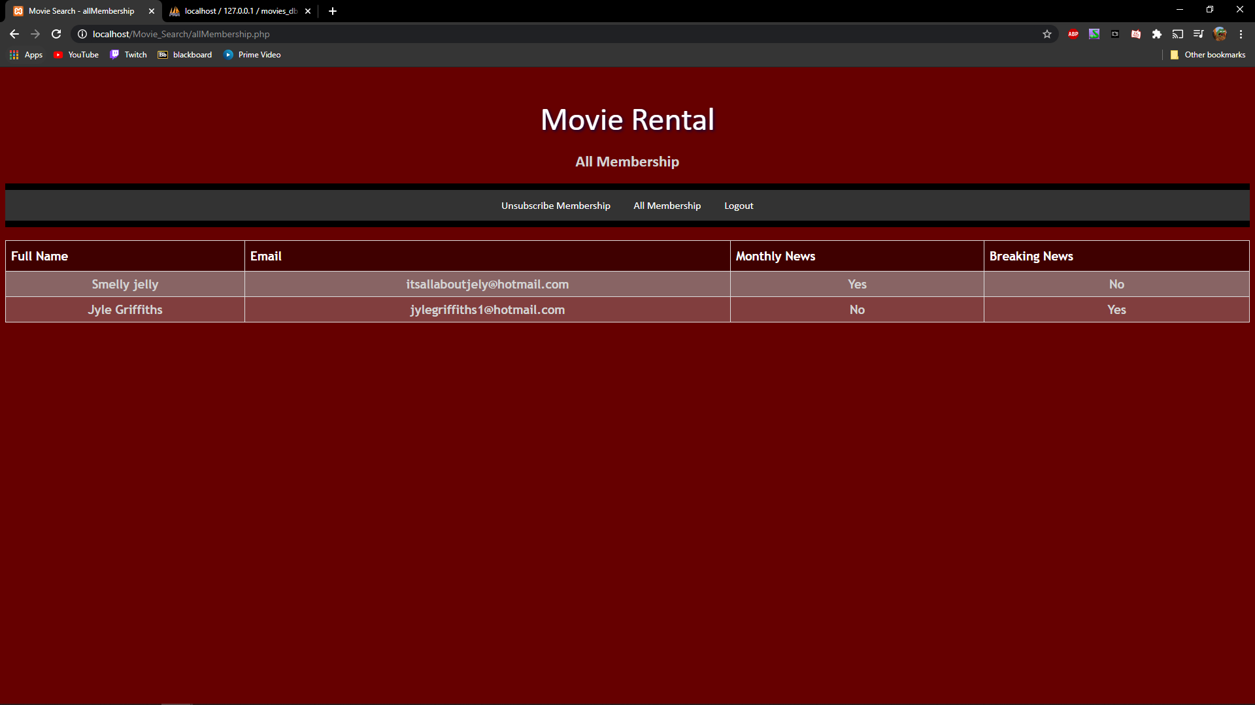

Figure 14

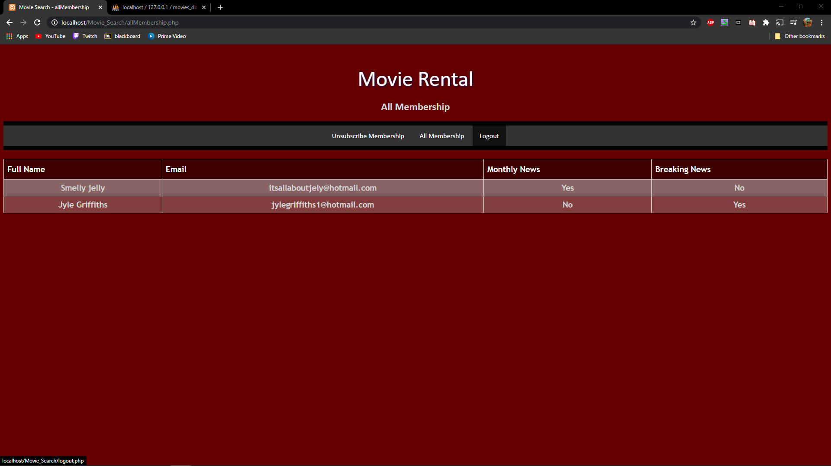

Figure 15

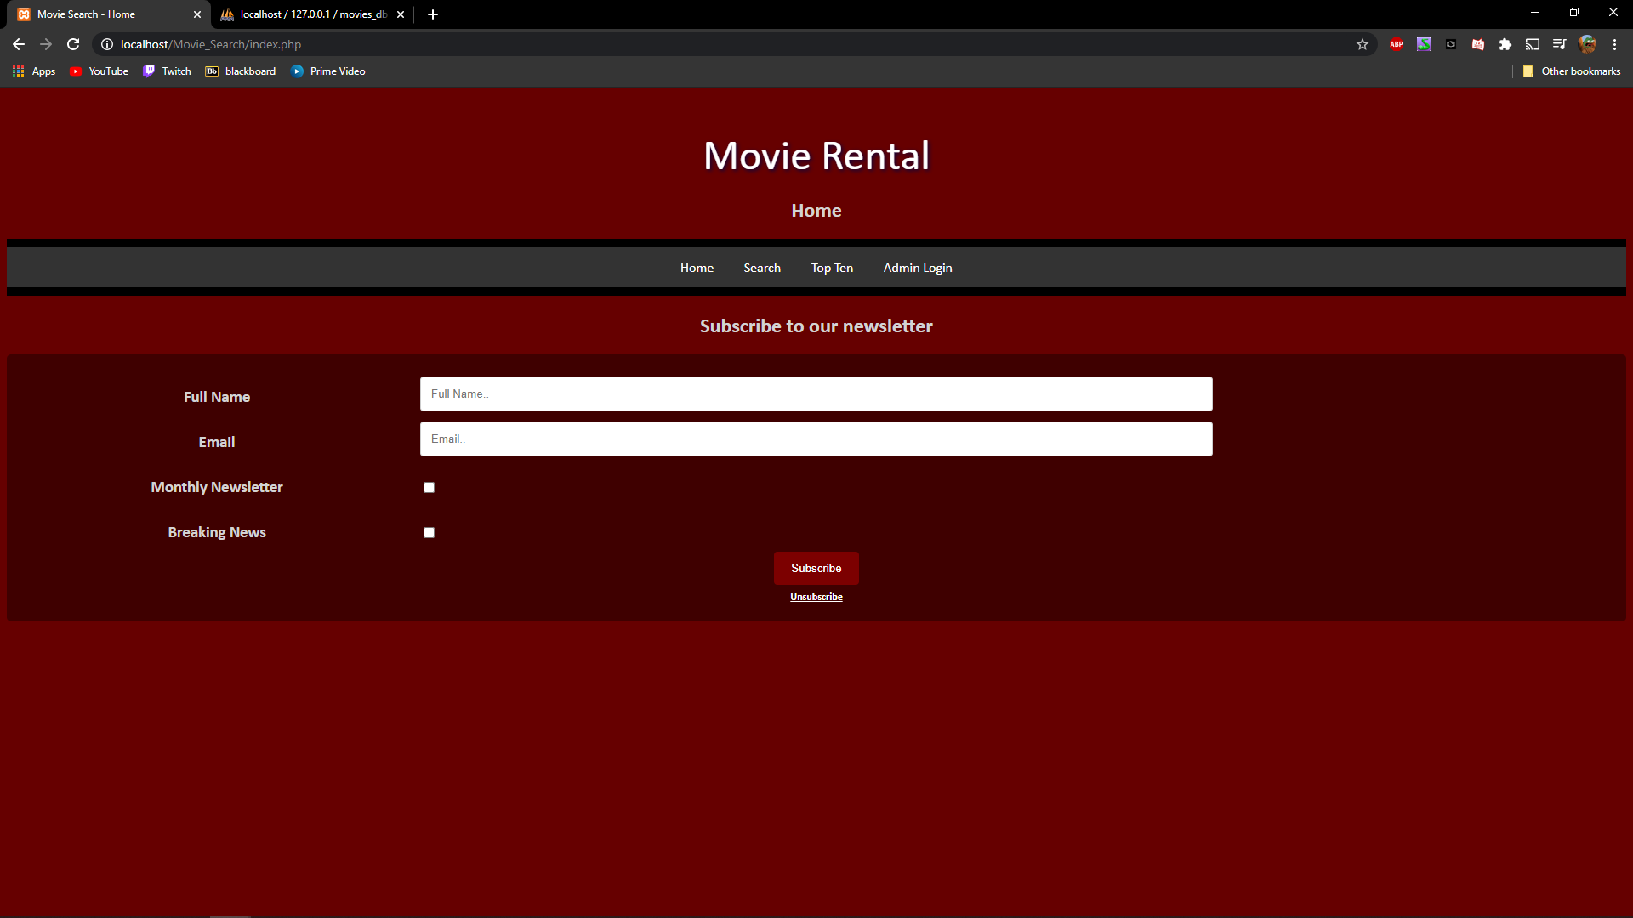

Figure 16

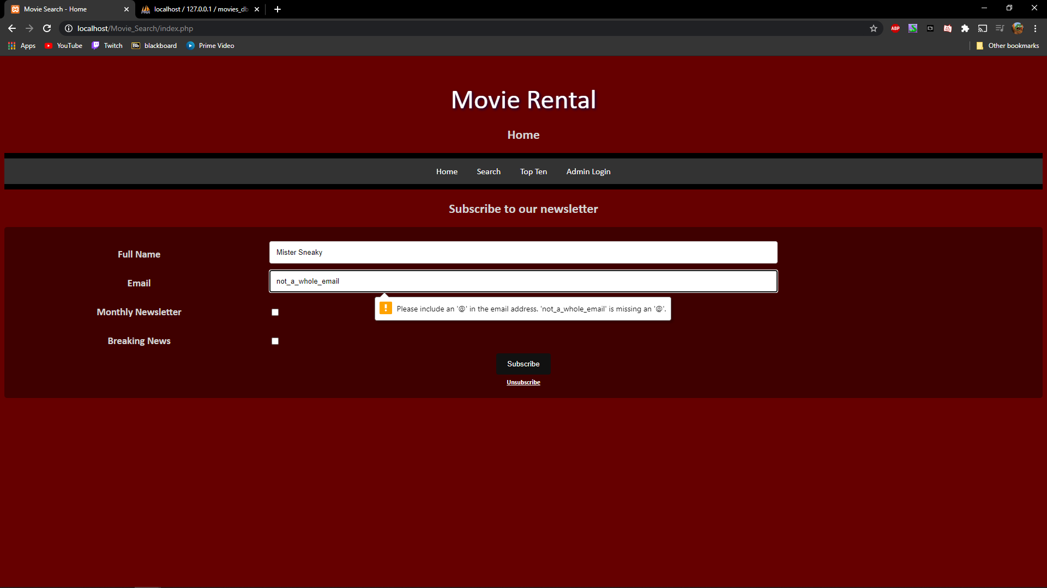

Figure 17